2.1 Project Background

Health is one of the most crucial concern for a human being. Now in this age with technology and diversity, many people have been neglecting their health due to either being distracted or becoming complacent, which is of course human nature. The Workout Tracker app aims to provide a healthy, effective and easy to implement routine to all those who wish to seek a healthy lifestyle. With this our goal is to allow our customers to enjoy this interactive technology as well reap its health benefits.

2.2 Project Scope

The Workout Tracker app is designed to present a customized workout routine based upon the users’ choices. We offer three plans: home exercise, powerlifting, and bodybuilding. The user will select a custom plan out of these only. Furthermore, the Workout Tracker app will provide a customized diet plan as well to cater the daily body requirement in order fully maximize the results obtained after a dedicated time period. It also considers diabetic and lactose intolerant users and provide them with a diet plan suitable to nurture them throughout the time period.

2.3 Not in Scope

The Workout Tracker app is not designed specifically for those who want to lose their weight. Although they can choose a common plan called home exercise that is designed to both lose weight and gain muscle doing home exercises, however, the app cannot cater the needs of users who have above 30% body fat. Furthermore, users having allergic reactions to certain diet components or have any other sensitive intolerance other to that which have been mentioned above, will not be able to benefit from this app.

2.4 Project Objectives

The Workout tracker app aims to provide a concrete solution to all those whose live busy lifestyle seeking to improve their health or find it difficult to go hire an effective personalized trainer due to time constraints or monetary disadvantage. Not only it offers a really effective home exercise plan but also those who go to the gym or have right machinery at home can benefit from its timely, well planned, well organized, customized, effective, and well researched plans. The diet plan mentions all the nutritional facts so that the user can keep track of their intake providing improvisation and flexibility of alternative choices the user can make in case he is not fond of a particular food item. The Workout Tracker app’s goal is to make a highly interactive and engaging platform that makes workout fun, challenging and easy to manage.

2.5 Stakeholders

The Stakeholders for this project include: the customers, the designers (UI designs), the developers (both frontend and backend), the researchers, and the owner/manager.

2.6 Operating Environment

The Workout tracker app is designed to work on both iOS and android operating environments as it takes its implementation from flutter and dart platforms.

2.7 System Constraints

Software constraints: The Workout Tracker App does not provide offline in-app functionality.

Hardware Constraints: The Workout Tracker App does not support desktop-based systems.

Cultural constraints: The Workout Tracker App only support English as primary mode of communication.

User constraints: The Workout Tracker App is designed for 16+ users only.

2.8 Assumptions and Dependency

The Workout tracker app does not give any explicit dependency, however, for the plans such as powerlifting and bodybuilding, it is assumed that the users have right machinery around them to execute these plans and they well aware how to use them in the right manner. The diets are customized; however, they do not cover all the wide variety of food items available all across the world. Due this reason nutritional facts are given to allow users to have a flexibility of choice with the available food items around them.

4.1 Functional hierarchy

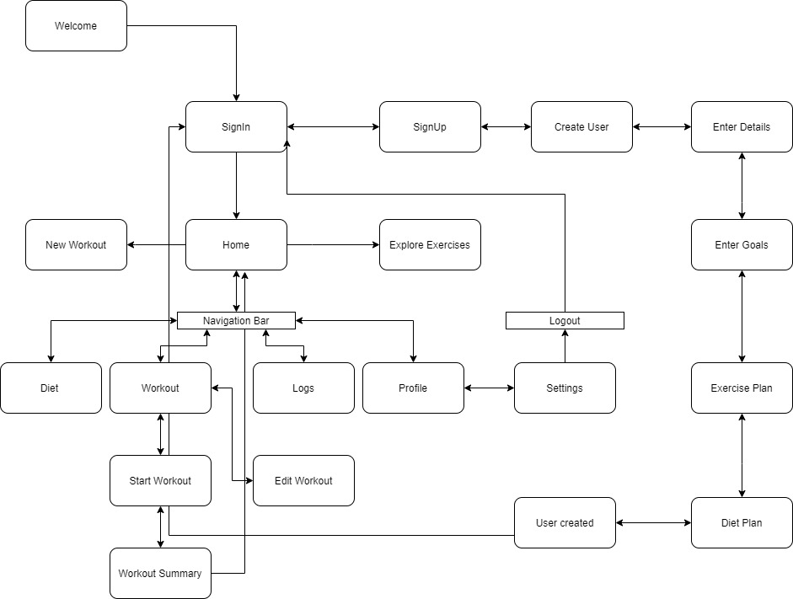

4.2

|  |  |
| --- | --- |
| ***Use Case Description*** | |
| ***Use Case name: Home*** |  |
| ***Use Case Description: Fitness Application setup and navigation*** | |
| ***Primary actor: User*** | ***Other actors: Database*** |
| ***Stakeholders: App Store*** |  |
| ***Relationships***   * ***Includes: Explore exercise, New Workout, Settings log, Diet plan, Workout routine, profile*** * ***Extends: Navigation*** | |
| ***Pre-conditions:***   * ***Internet Connection*** * ***Register as User*** * ***Logged in as User*** | |
| ***Flow of Events:***   1. ***After successfully logging in, the user can navigate in the app using the navigation bar*** 2. ***The user may choose between home, workout, diet, log and profile*** 3. ***In home the user can navigate to explore exercises or set up a new workout*** 4. ***In workout the user can start and complete his daily workouts*** 5. ***In diet the user can see his daily diet plan*** 6. ***In logs the user can see his daily workout history and clear them*** 7. ***In profile the user can view his stats or go to settings*** 8. ***The user can change settings which include changing name, setting workout alarm or toggle between color modes*** 9. ***The user can also logout through the settings page*** | |
|  | |
|  | |

|  |  |
| --- | --- |
| ***Use Case Description*** | |
| ***Use Case name: SignUp*** |  |
| ***Use Case Description: Fitness Application setup and navigation*** | |
| ***Primary actor: User*** | ***Other actors: Database*** |
| ***Stakeholders: App Store*** |  |
| ***Relationships***   * ***Includes: Validate Credentials, Create User Enter Goals*** * ***Extends: Login*** | |
| ***Pre-conditions:***   * ***Internet Connection*** * ***Register as User*** | |
| ***Flow of Events:***   1. ***User registers account by signing up and entering their details*** 2. ***User chooses their workout and diet plan*** 3. ***User is navigated to the login page to login*** | |
| ***Alternative and exceptional flows:***   1. ***The user will be prompted if a user with same name or email already exists*** 2. ***The user will be prompted if wrong username or password is insert*** | |
|  | |

Use Case Diagram

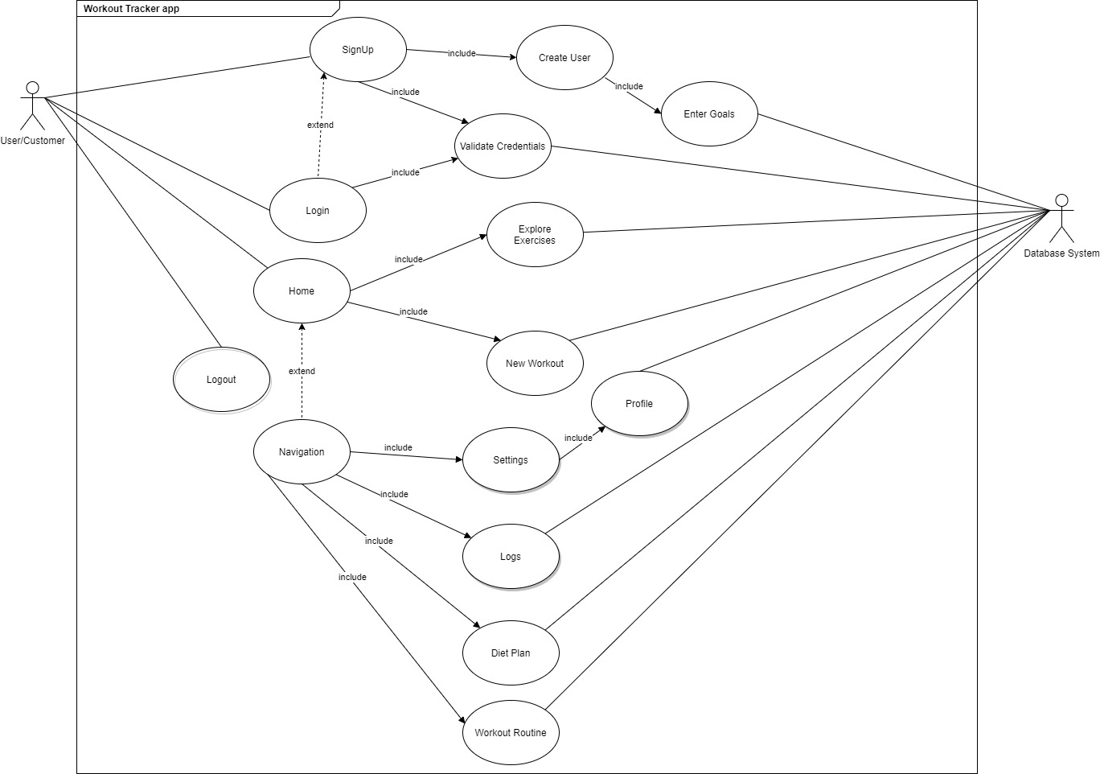

Sequence Diagram

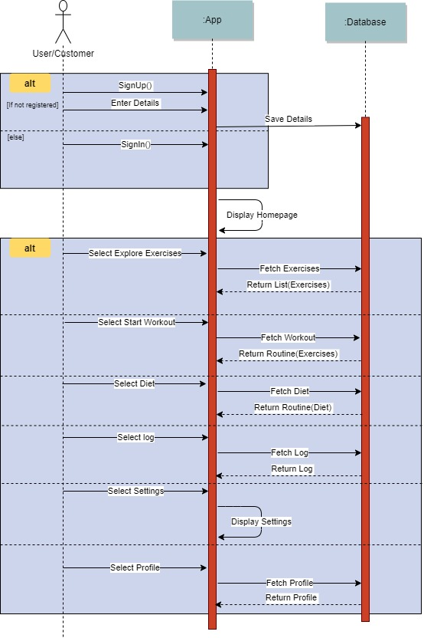

Activity Diagram

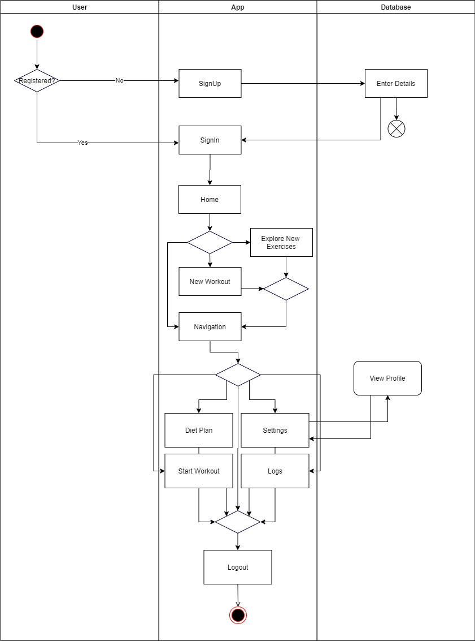

State Chart Diagram

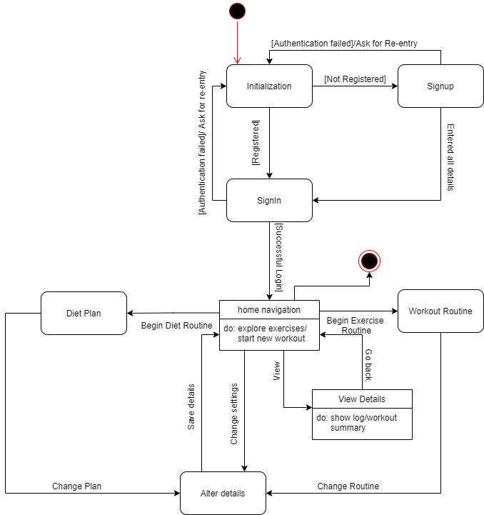

Deployment Diagram

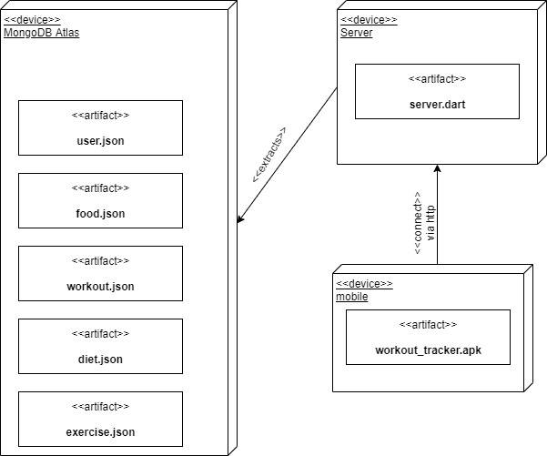

Class Diagram